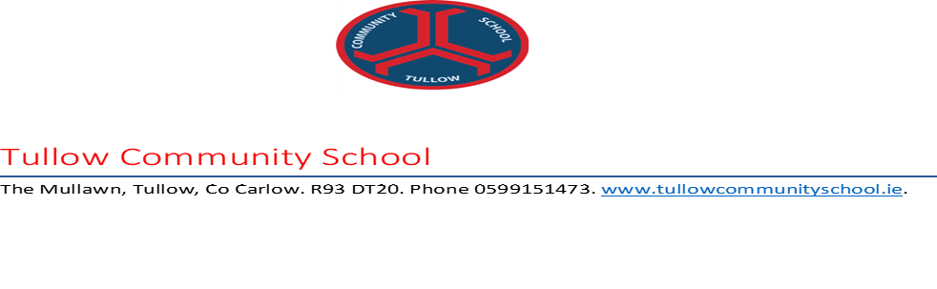
Dear Candidate
We hope you enjoyed your Summer holidays and that you and your family are keeping well and safe as we negotiate our way through the remaining Covid restrictions.
This is an exciting and perhaps anxious time for you as you await your Leaving Certificate results. As the day approaches, we wish to update you on the arrangements for accessing your results.
Results
- On Friday 3rd September at 10 am, you can view your results using the Candidate Self-Service Portal.
- At that stage, you will also be able to print a Statement of your results. We strongly advise that you do this as the school no longer receives a Statement of your results on the day because of the changed circumstances due to Covid 19.
- Unfortunately, due to the changed circumstances and in order to minimise the risk of infection for students, families and the wider community, the school is not in a position to invite candidates to view their results on the premises.
- However, if there is a particular issue in relation to your results that you would like to discuss, or if you feel you need support on the day, you are welcome to contact the school between 11am and 1pm to access the Guidance Counsellor, Chaplain or Exams Secretary.
- The wellbeing of candidates will also be supported by the helpline provided by The National Parents’ Council at 1800 265 165 from 11 am on Friday.

Viewing of Scripts/Appeals
Every year, a small number of candidates opt to view their scripts.
This year, viewing of scripts will be held either in school or online depending on whether the subject was marked on paper or online.
- The physical viewing process will take place in the school on Saturday 11th September.
Session 1. 9am-11am
Session 2. 12 noon-2pm
- Online viewing of subjects is delivered through the Self-Service Portal and will be available from 9am on Saturday 11th Sept to 12 noon on Sunday 12th September. Online viewing will not take place in school.
- Teachers will not be available to view scripts with you unless you have made prior arrangements with them.
- If you wish to view your script, you must apply to do so. You will have from 5 pm on Tuesday 7th September until 8 pm on Wednesday 8th September to make your viewing application.
- If you wish to appeal a result, you may do so through the Candidate portal from 9 am on Saturday 11th September to 12 noon on Monday 13th September. There is no fee.

All these details, along with more in-depth information, are available on the Examinations website. You are also welcome to contact the school if you have specific questions.
We wish to take this opportunity to congratulate you on your resilience during two very challenging school years and to wish you happiness and fulfilment in your future.

Yours sincerely

Martina Fogarty
(Exams Secretary)
Paul Thornton
Principal

