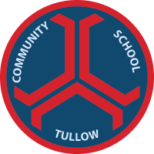

Tullow Community School
The Mullawn, Tullow, Co Carlow. R93 DT20. Phone 0599151473. www.tullowcommunityschool.ie.
20th May 2021
Dear Parents/ Guardians,

As you are aware the school is introducing a compulsory P.E. uniform which must be worn by students on the days that they have P.E. class.

After a tender process and vote by students and parents DS sports was selected as the supplier of the PE uniforms. Local company Rathbawn Embroidery have agreed a deal with DS sports so they can stock the uniform along with the normal school uniform.

This means the uniform can be purchased from DS sports online direct at the prices and link below or from Rathbawn for a small extra fee making it very convenient for parents to purchase both uniforms in the same location

The P.E. pack offers a discount, but items can also be bought individually. The P.E. uniform consists of the half zip top, T-Shirt and Tracksuit bottom as pictured below.
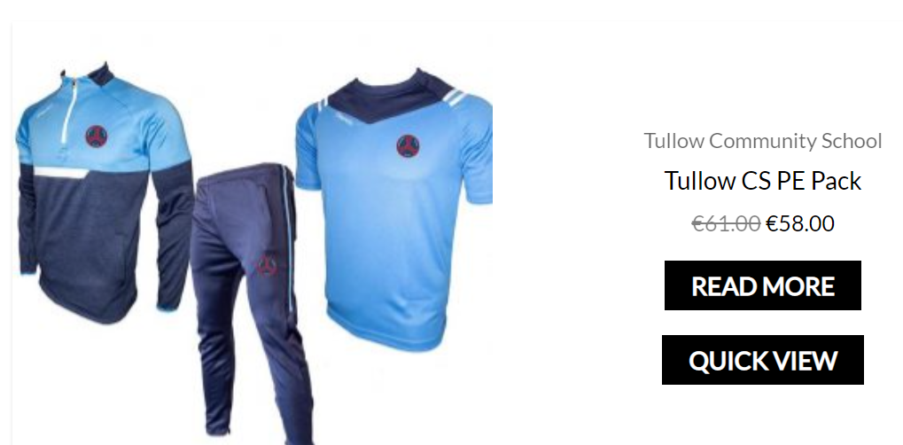
https://www.dssports.ie/product-category/my-club/tullow-community-school/

There are also some optional items which are available to buy on the site.
All the items below are optional and there is no obligation to purchase.

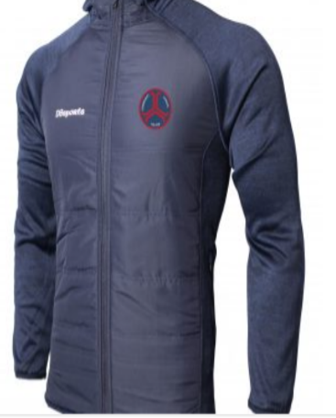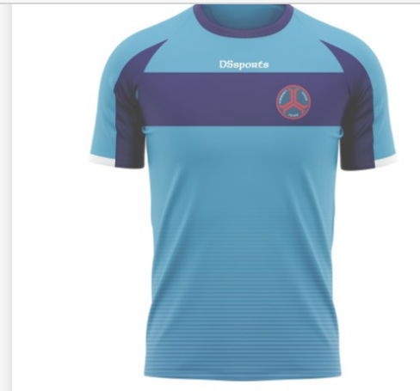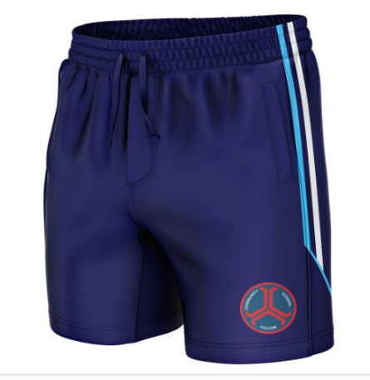

Prices from local seller Rathbawn for PE uniform are as follows.

3 Pack €69
½ Zip €29
Bottom €26
Tshirt €18
Shorts €20
Training top €34

