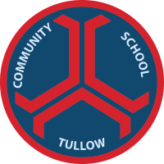

Tullow Community School
The Mullawn, Tullow, Co Carlow. R93 DT20. Phone 0599151473. www.tullowcommunityschool.ie.
20th May 2021
Dear Parents/ Guardians,

As you are aware the school is introducing a compulsory P.E. uniform which must be worn by students on the days that they have P.E. class. The uniform was completely designed by the students. The colours, design and style were chosen from the survey results and the Parents’ Association were also involved with the process. We are very happy with the finished product, and it can be purchased from the supplier DS Sports directly at the link below. The suppliers will be in the school canteen this Monday, 24th for any student who would like to try on a top for size. However, items can be returned if they do not fit. The P.E. pack will be available within a week of ordering, but the optional items will have a six week wait as they are not a stock item. For any student who does not want a skinny style tracksuit bottoms, you can contact DS Sports directly and they will supply a standard style tracksuit with same design and crest.

Yours Sincerely

Paul Thornton
Principal

The P.E. pack offers a discount, but items can also be bought individually. The P.E. uniform consists of the half zip top, T-Shirt and Tracksuit bottom as pictured below.
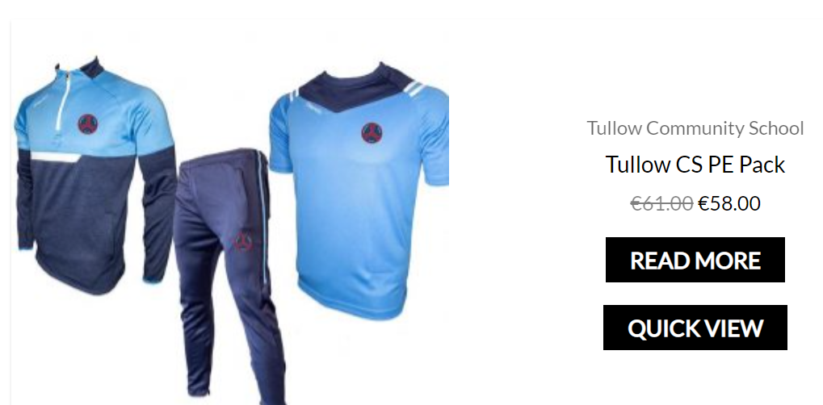
https://www.dssports.ie/product-category/my-club/tullow-community-school/

There are also some optional items which are available to buy on the site. A large number of students requested shorts as part of the P.E. uniform and this is also available on the site along with a training jersey for all the school sports teams or the jersey can be worn instead of the P.E. T-Shirt on P.E. days. There is also a school jacket for any parents that may wish to purchase a jacket for rainy days.
All the items below are optional and there is no obligation to purchase.

