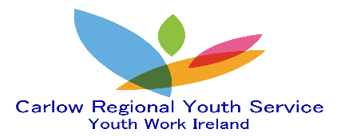

Tullow Youth Project

Carlow Regional Youth Service @ Tullow Youth Project is situated at Bishop’s House, Tullow. We work collectively with young people to enhance their social and personal development skills by implementing evidence based-informed youth work programmes and non-formal educational opportunities including:

- Structured small group work: Sport, Arts, Drama, STEAM, Gaming, Culinary, Fly Fishing, Music Mentoring/ Lessons, Positive Mental, Physical and Sexual Health programmes and alternative Interest based programmes etc.
- Unscheduled Interventions: Young people can contact Youth Workers to discuss topics of interest.
- Structured group work: Structured Drop-In, Youth Forums, Youth Committees, Leadership/Volunteer Training and alternative Issue based programmes etc.
- Specialised Provision Work: One to One & small group for vulnerable young people by means of Coaching -Mentoring, Crisis-Therapeutic Intervention/Support.
- Teenage Summer Programmes: Consist of Interest based programmes, Including Day Excursions.
- Transitions Programme: Implementing evidence-based programmes to reduce anxiety and develop resilience in 6th class students transitioning from primary level to secondary level school.
- Advocacy Work: Advocating on behalf of a young person or group of young people to meet their needs.
- Community Partnership: Young People engage in a variety of activities to develop relationships and gain a sense of belonging within their community.
- Outreach: To support young people that are socially isolated and unaware of the service we provide.

Who do we work with?
We work collectively with young people age 12 -24 years.

What can Young People expect?
A safe, friendly, fun, non-judgemental, inclusive youth centred environment where young people are visible, equally valued and respected for their own individuality. Young people have their views heard and are involved in the decision -making process.

What can Parents expect?
We are part of an integrated youth service and the safety and welfare of all young people is of paramount importance. Parents can be assured that staff are accredited, Garda Vetted and receive continuous professional development to provide the best positive outcomes for all young people.

Opening Hours: Monday -Friday 2pm -8pm
Due to Covid -19 pandemic all visits are required to be prearranged with Staff.

For additional information, please contact:
Tullow Youth Project@ Bishop’s House: 0599152297
Cathy on 0858338732 email cathy@carlowys.ie
Armand on 0867806406 email armand@carlowys.ie
Emma on 0867806405 email emma@carlowys.ie

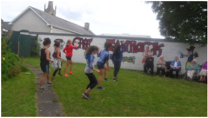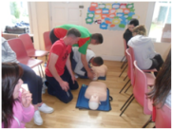
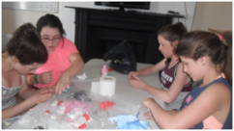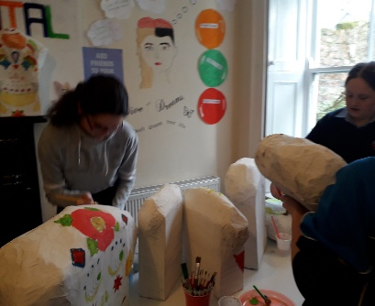
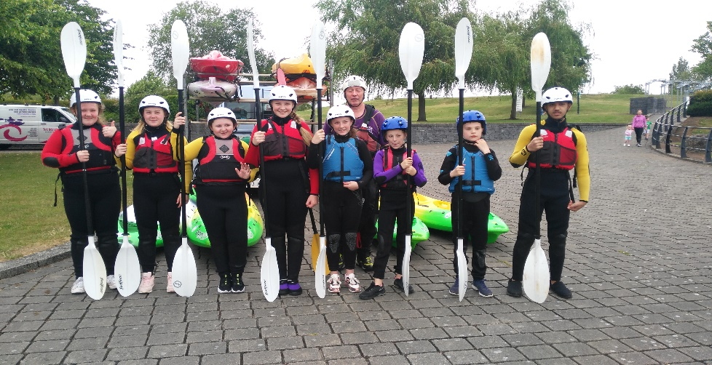
‘We work to empower young people to achieve their potential through quality youth work’

