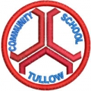Tullow Community School

OPEN EVENING
(for 5th & 6th class pupils)
Thursday 8th November 2018
7.00 p.m. – 9.00 p.m.

