Transition Year Trip Spain- March 2018
Pamplona & Canchandu
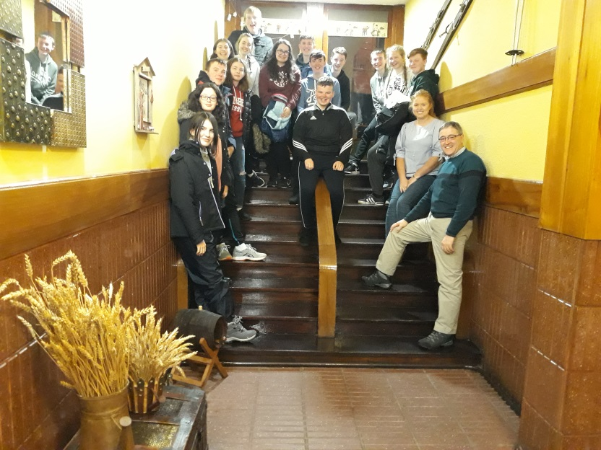
Day 1
It was an early rise for sixteen very enthusiastic students and two teachers who left Tullow at 6.30 am to journey to Dublin airport. Bright eyed and bushy tailed we arrived to the airport but not without any drama or excitement, 18 passengers and 17 passports… thankfully the last passport arrived just in the nick of time before we had to go through airport security!
We arrived to Bilbao airport unscathed and began our two hour bus journey to the city of Pamplona. Here, the students and teachers got the opportunity to explore what the city had to offer and also got to sample some of the local ‘Pinxtos’ or Tapas as we may be more familiar with.
Day 2
Friday was a very exciting day for all as we got the opportunity to visit a Spanish Secondary School. Here, the Irish students got to meet their Spanish counterparts who brought us on a jaw dropping tour of their spectacular school campus which had fantastic amenities such as sports pitches, swimming pool, gym and even a jacuzzi to name but a few. Our Irish students then split into smaller groups where they communicated with the Spanish students showcasing what the Transition Year system is like in Ireland; students did us very proud here.
After the educational experience in the school we hit the shops! With money burning a hole in our pockets we made the most of the rainy Spanish evening and stayed indoors buying presents and momentos to bring home to family members.
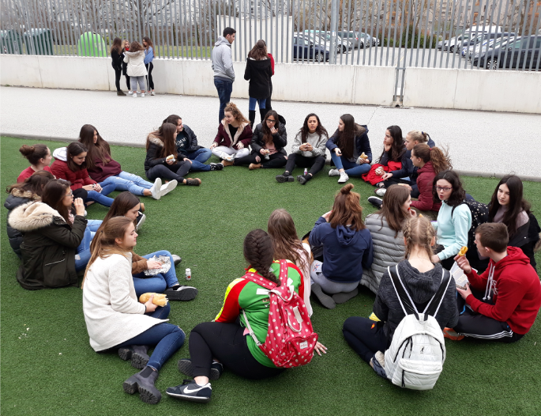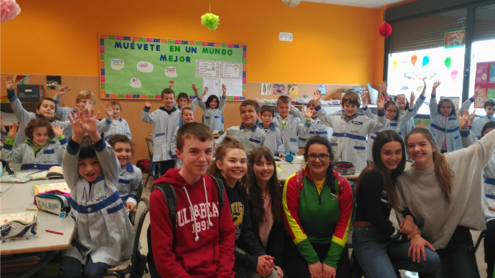

Day 3
With our walking shoes at the ready we set off with our tour guide, Martin, who brought us on a walking tour of Pamplona; we experienced the historical element of the city and also got a snapshot of the fantastic Camino walk which thousands of pilgrims tread every year. Following this we visited the Bull Fighting Museum where students learned about the festival ‘San Fermin’ which takes place in Spain every July. Day three concluded with a visit to the local shopping Centre, La Morea, for more retail therapy and most importantly food at McDonalds!
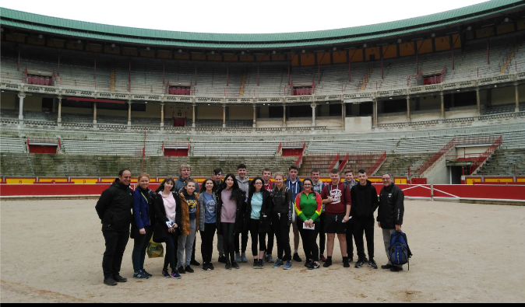
Day 4
Day four involved something entirely different to our experience of the first few days. We left Pamplona and took the two hour bus journey to the ski resort of Canchandu. The students and teachers were extremely excited for this adventure as it was something new and we were hoping for an adrenalin rush and we were not disappointed.
Suited and booted in our thermal ski gear we met our ski instructor Tatiana who instructed us on the basics of skiing and before long we set off up the mountain like a line of young ducklings. Many took to it like a duck to water, others maybe not so much but it was the fun and taking part that counted and all agreed that skiing was an amazing experience, with many thinking about their next ski holiday already.
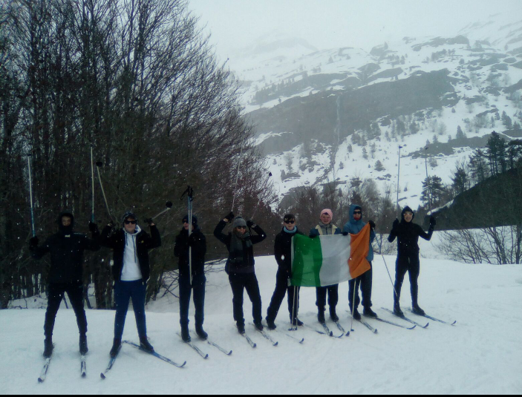

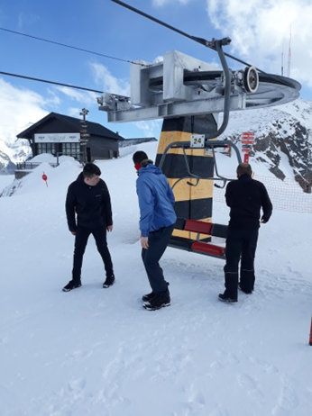

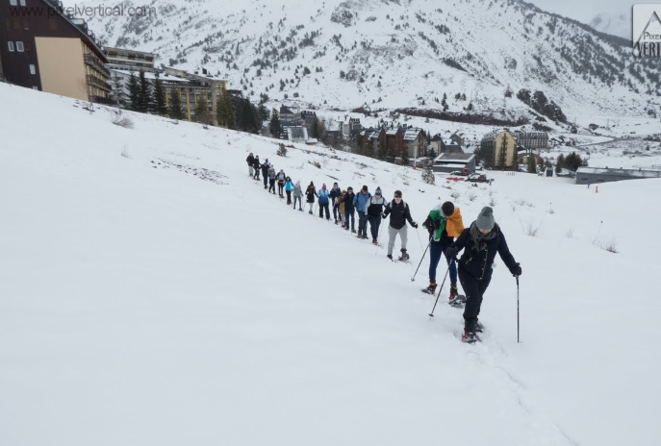
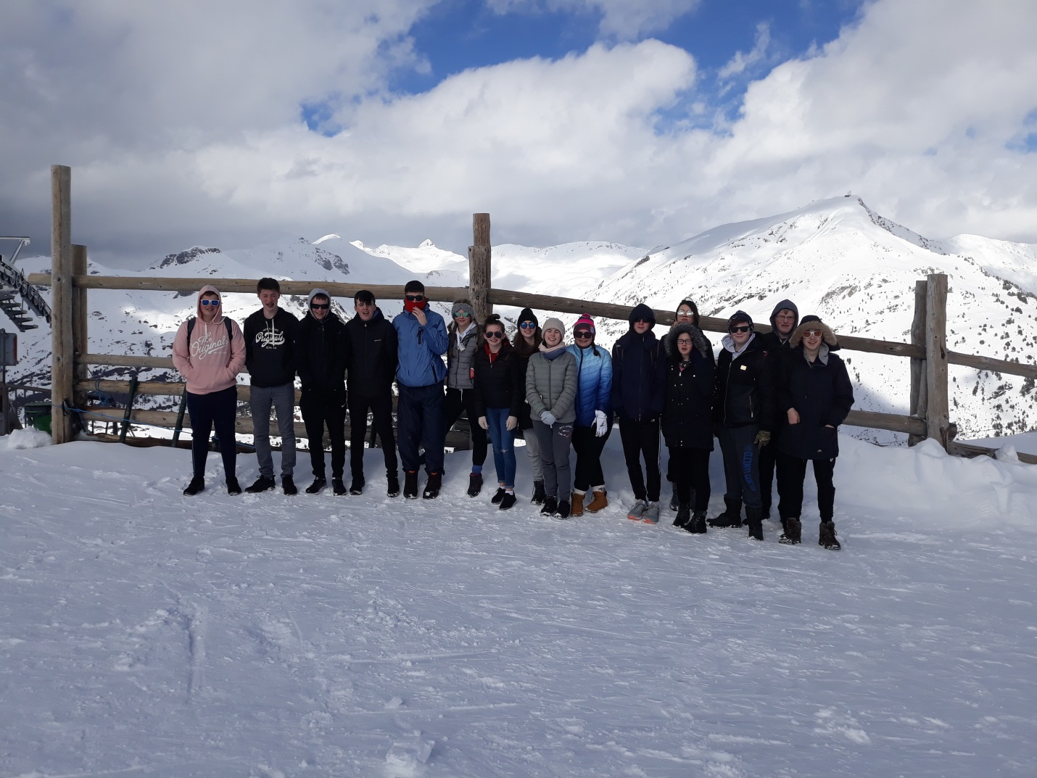
Day 5
Survival of the fittest! Today saw us donning our ski racquets to take to the mountains for a strenuous two hour hike! Sixteen students and two teachers set off with our instructor Raul with only eight students and one teacher making it over the finish line! Don’t worry we didn’t leave anyone behind; instead they opted to head back as a group to the warmth of their hostel room.
While on the trek it was a case of channeling our inner Bear Gryll’s survival skills as we learned how to rescue a victim of an avalanche! The students took part fully and really immersed themselves in the unique experience. One of which I hope we never have to put into practice! The eight students and one teacher made it back to the hostel unscathed, more or less except for the iconic case of ski sunburn which resembled the look of a red panda, for some.
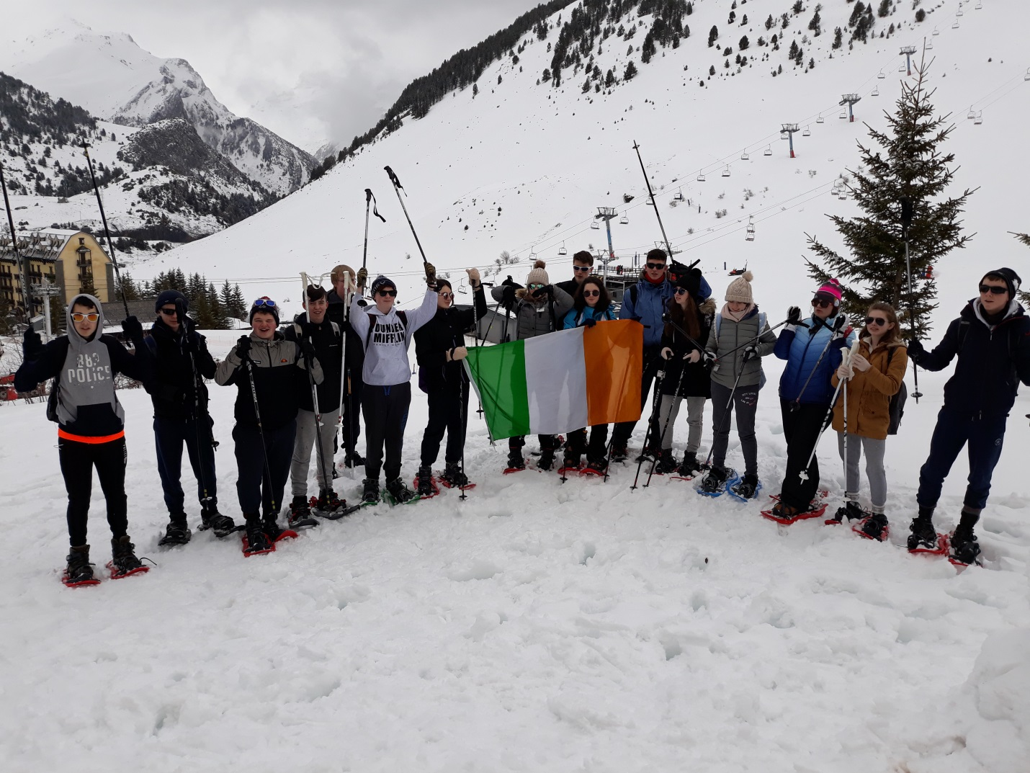
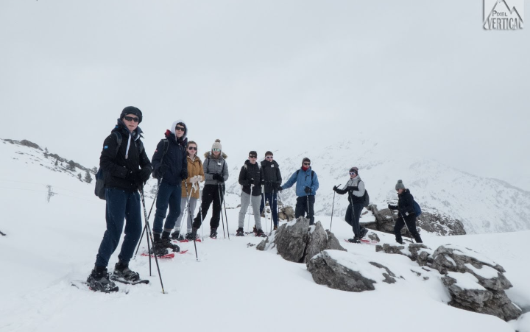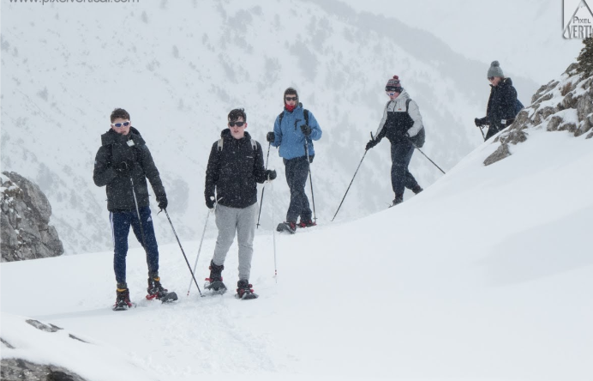
Day 6
The early bird catches the worm! We were up bright and early for breakfast on our last day as we had a long drive to Bilbao airport. Students ascended the bus with bags and suitcases in tow. We had a long day of travelling ahead of us. We boarded our flight, landed safely in Dublin airport and then took our last leg of the trip by bus to Tullow where students were greeted by family who were there eagerly awaiting their return.
A fantastic trip was had by all!
Ms Grufferty
March 2018

