Let's Have Fun! Wins Carlow County Enterprise Award 2018
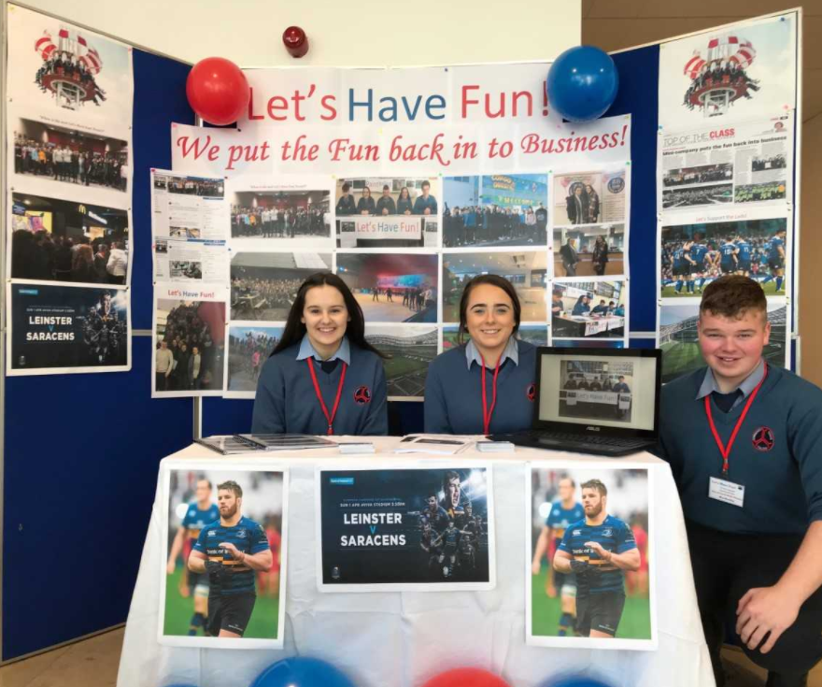 | 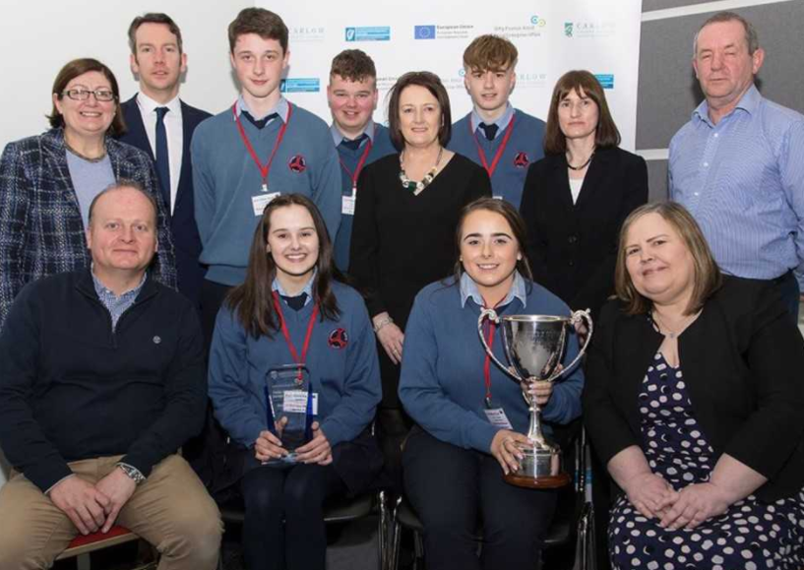 | 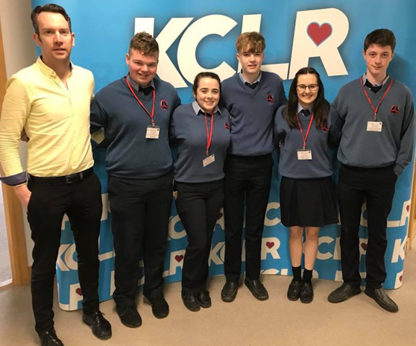 | 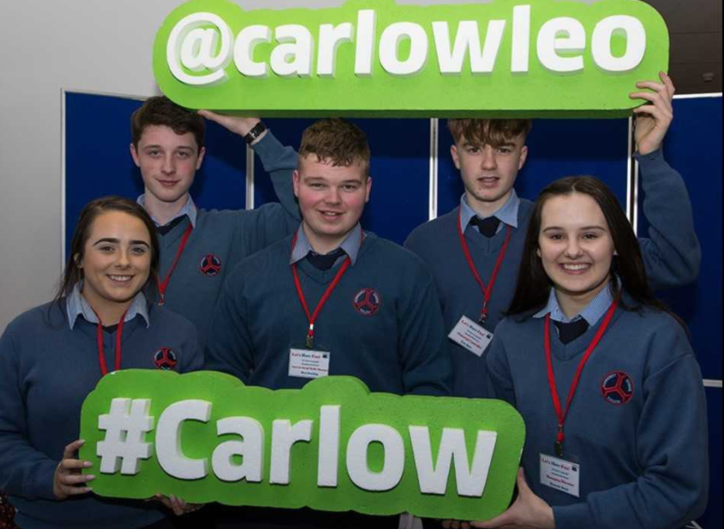
Tullow C.S. Students Hannah Doyle, Rachel Broughan & Ben Dowling at their Let’s Have Fun! Company Stand at the Carlow County Enterprise Awards 2018. | Tullow C.S. Enterprise Teacher Mr. Brian Larkin with students from the Transition Year Company Let’s Have Fun! Tomas Aughney, Ben Dowling, Eric Barr, Hannah Doyle and Rachel Broughan having just won the Carlow County Enterprise Award 2018. | Tullow C.S. Enterprise Teacher Mr. Brian Larkin with the Let’s Have Fun! Students Ben Dowling, Rachel Broughan, Eric Barr, Hannah Doyle and Tomas Aughney just before being interviewed on KCLR Radio having won the overall Carlow County Enterprise Award 2018. | Rachel Broughan, Tomas Aughney, Ben Dowling, Eric Barr  and Hannah Doyle from Let’s Have Fun! will now go on to  represent County Carlow at the National Enterprise Awards  in Croke Park on the 2nd of May 2018. We wish them Luck.!

Let’s Have Fun! a Transition Year Company from Tullow Community School won the Overall Carlow County Enterprise Award 2018 at the Enterprise Awards Ceremony held in the Institute of Technology Carlow recently. They will now go on to represent County Carlow at the National Enterprise Awards being held in Croke Park on the 2nd of May 2018. Tullow C.S. submitted four Company's to the Carlow County Enterprise Awards where the high standard of their Company's was recognised by receiving two of the top awards.
Let’s Have Fun! consisting of Hannah Doyle, Rachel Broughan, Ben Dowling, Eric Barr and Tomas Aughney set up a Company to provide an Event Management Service that organises Fun! Events for their Customers to go to. We were just sitting as a group of friends brainstorming ideas for our Company back in September when we realised that the annual Tullow Muck Fest was no longer taking place. Having first-hand experience of the muck fest ourselves we remembered how much fun it was, but also how popular it was! We saw this as a huge gap in the market that was no longer being catered for. We decided to step in to that gap and develop the idea further. Things have just snowballed for us as a Company since then with an ever-increasing demand for our Fun Events! So far, we have brought over 90 Students Ice Skating, over 50 Students Paintballing, over 30 Primary School Students Bowling and just last weekend we brought over 50 Students to the European Cup Quarter Final between Leinster and Saracens in the Aviva Stadium! To date we have generated a Total Income from Sales of €5250.00 with a Net Profit of €1550.00! We are delighted to have won the Overall Carlow County Enterprise Award 2018 and we are really proud to be representing County Carlow at the National Enterprise Awards in Croke Park on the 2nd of May 2018! Keep an eye out for our next fun event on our Let’s Have Fun! Facebook page.

ZipIt Clothing consisting of Holly Ward, Ava Clarke, David Orbinski and Kieran Orbinski set up a Company to provide Half Zip Sports Tops to both Secondary and Primary School Students. They got their idea when they realised that their own School had a number of different Sports Tops for different teams in the School. They decided to design one Half Zip Sports Top that would represent the School as a whole. They sold these Half Zip Sports top to Primary and Secondary School students which were designed to meet each School’s individual requirements. They have also successfully negotiated Sponsorship with two Companies to provide financial backing for the Sports Tops. To date they have generated a Total Income from Sales of over €5500.00 with a Net Profit of €1,500.00. Right now, they are processing an order for another 60 TY Half Zip Sports Tops for the Third Years going in to Transition Year next September in Tullow C.S.! ZipIt Clothing won the award for the Best Business Report 2018 at the Carlow County Enterprise Awards recently.

Pops R Us! consisting of Zoe Hynes O’Reilly and Katelyn Bulmer Smithers set up a Company to provide Pop Plugs which go on to the back of your Mobile Phone or Tablet device. They purchase the Pop Plugs in bulk at a price of 65 cent each and sell them for €5 each. This provides them with an 87% Net Profit Margin. Their selling price is also competitive as most of the shops in Carlow are selling them for €7 or more. So far, they generated a Total Income from Sales of €1350.00 with a Net Profit of over €1000.00. Right now, they are processing an order for 500 Pop Plugs for a Company that wants their Company Logo on them so that they can hand them out to their Customers as a marketing tool! They represented their Company really well and did the School proud at the Carlow County Enterprise Awards.

Slate Visions consisting of Naomi Stewart Williamson, Kiril Mamosin and Michael Aughney set up a Company to provide people with the opportunity to get some of their favourite images lasered on to slates of different sizes. They provided their Customers with a Catalogue of over 250 images to chose from and also took peoples individual orders at their Company email address slatevisions@gmail.com. To date, they have generated a Total Income from Sales of €640.00 with a Net Profit of €265.00. Right now, they are taking orders for Sixth Class Graduation Photos on a Size A4 Slate!

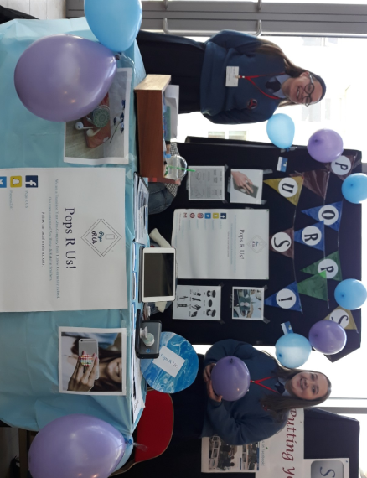 | 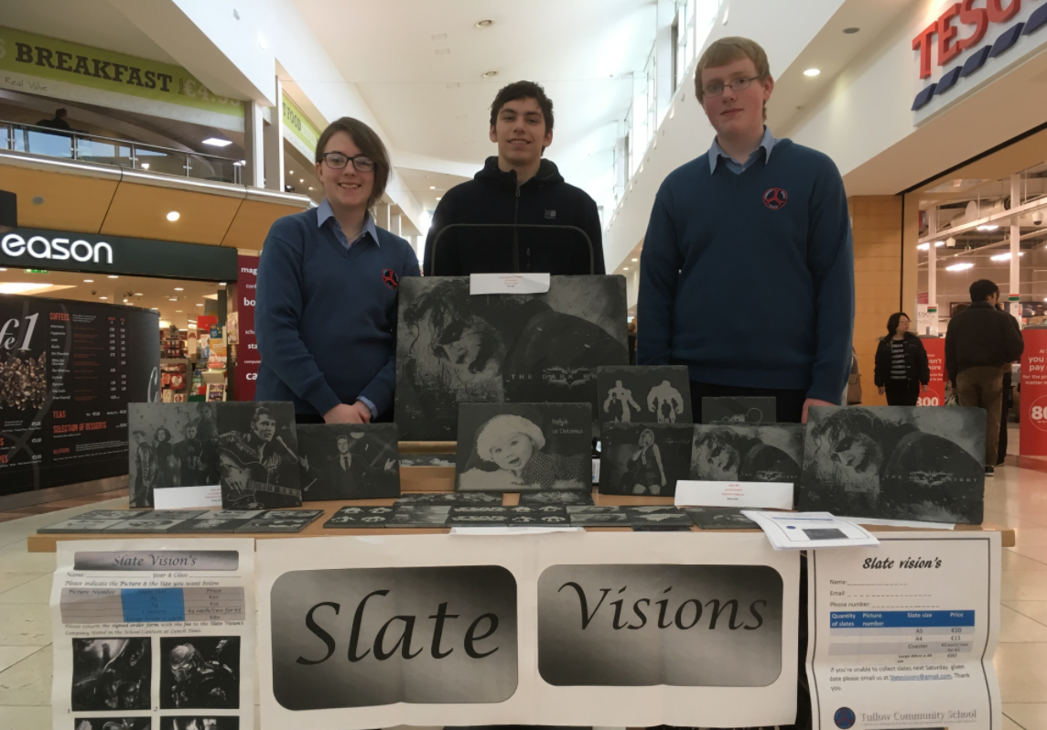 | 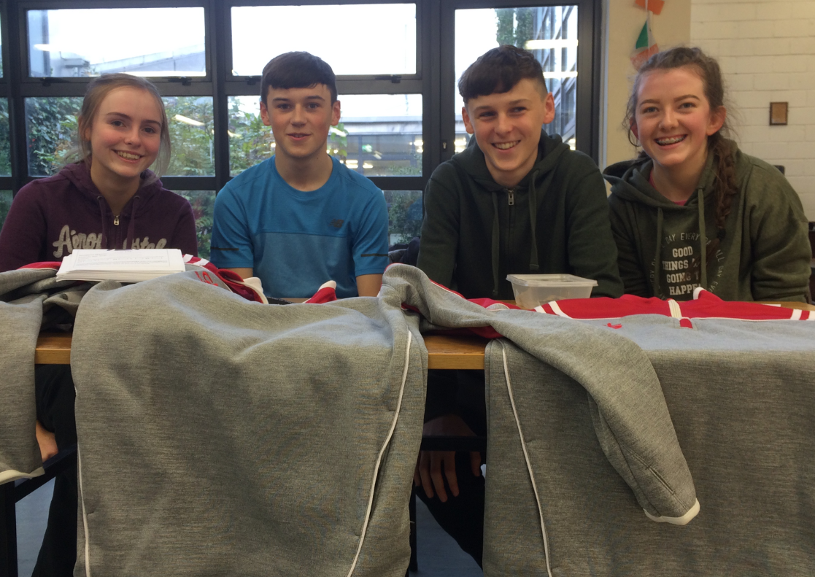 |  | 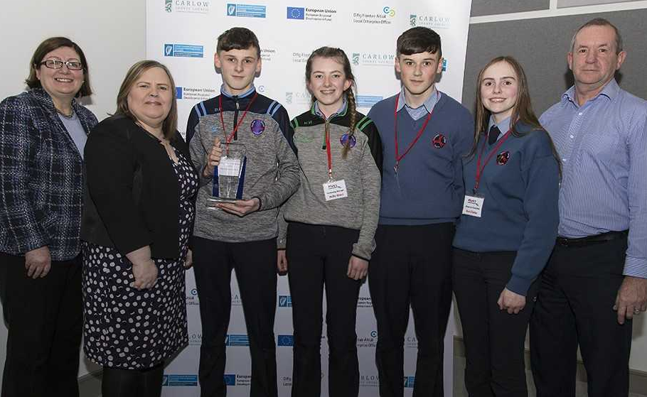
Tullow C.S. Students Zoe Hynes O’Reilly & Katelyn Bulmer Smithers at their Pops R Us! Company Stand at the Carlow County Enterprise Awards 2018. | Tullow C.S. Students Naomi Stewart Williamson, Kiril Mamosin & Michael Aughney at their Slate Visions Company Stand in the Fairgreen Shopping Centre Carlow earlier in the year. |  | Tullow C.S. Transition Year Students Ava Clarke, Kieran Orbinski, David Orbinski & Holly Ward at their ZipIt Clothing Company Stand in the School Canteen earlier in the year. | Tullow C.S. Students David Orbinski, Holly Ward, Kieran  Orbinski & Ava Clarke receiving the Best Business Report  Award 2018 at the Carlow County Enterprise Awards for  their Transition Year Company ZipIt Clothing.

