Active schools week May 15th – 19th 2017
Day one
Monday saw active schools week kick off with wake up shake up at registration when every student was put through their paces for morning exercise. We then had drop everything and exercise for period 3.
Lunch time saw our first main event for the week when the 6th years took on the teachers in a Volleyball match. Having been unbeaten for many years the teachers went in as clear favourites but were left shell shocked when they found themselves nine points to one down early on. They fought back to make it 9 all and from here it was neck and neck with the lead changing hands all the time until it made it to 19 all when the students won five in a row to set themselves up with 5 match points and lead 24 19. Amazingly the teachers saved all five match points to draw level at 24 all and the with rules stating you must win by 2 the game got very nervous with the teachers never taking the lead and having to save a match point every time until it reached 28 27 and the pupils won.
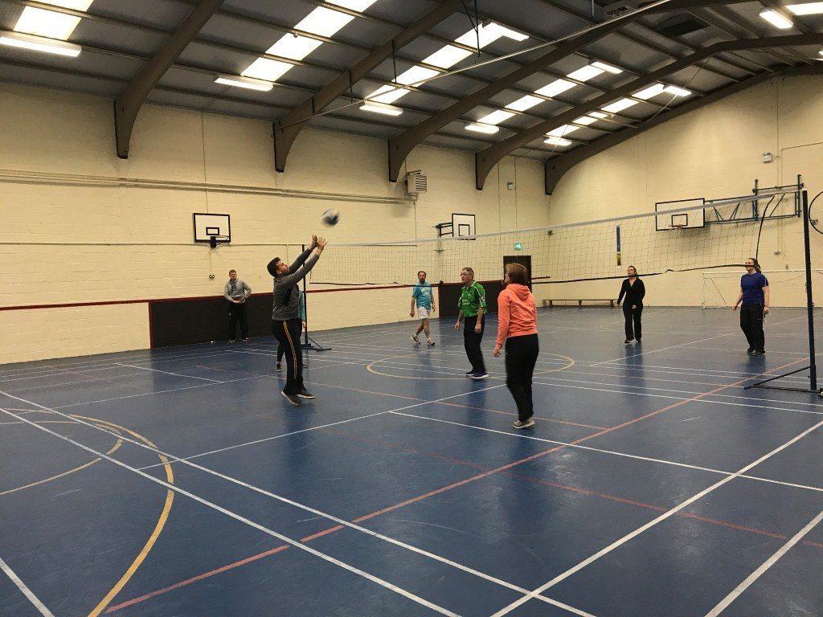

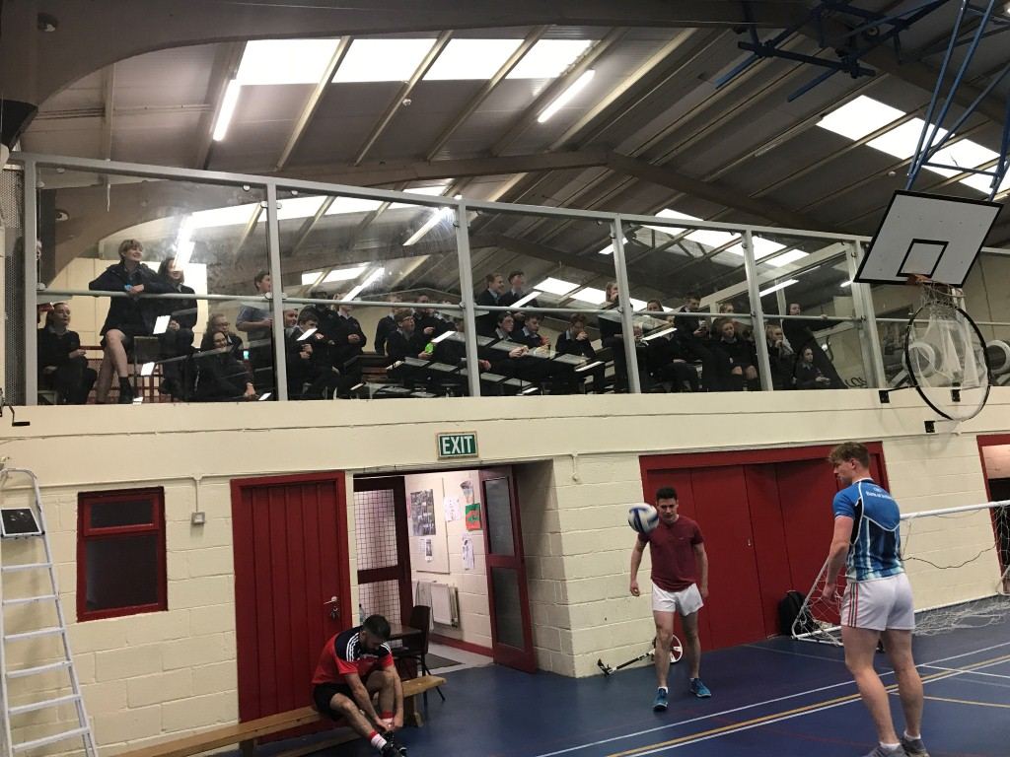
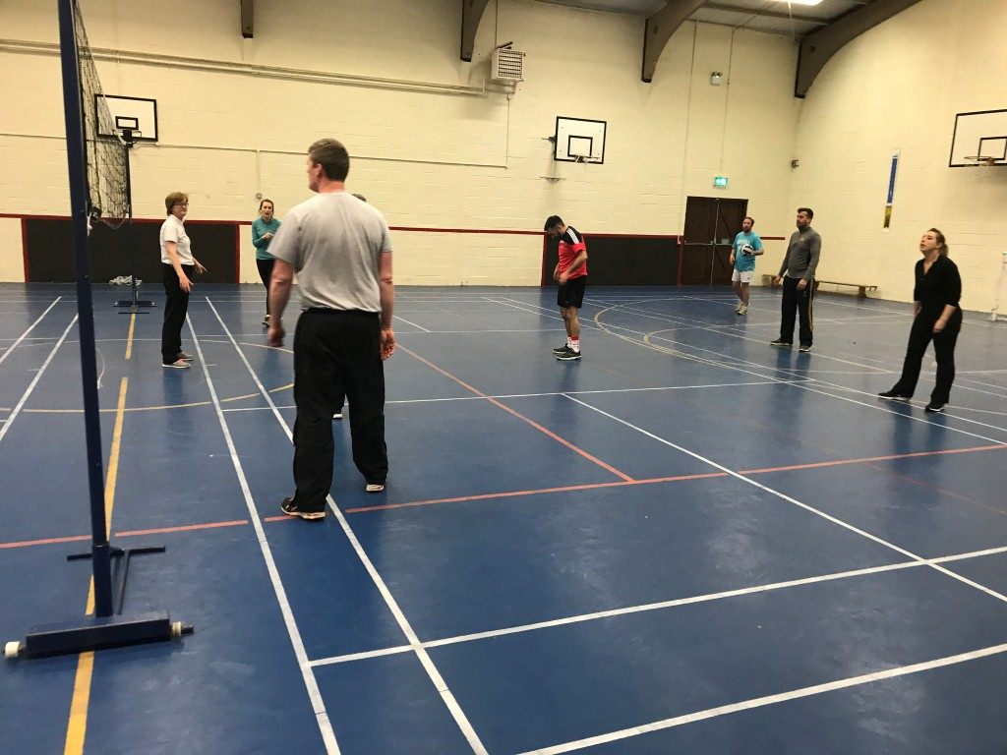
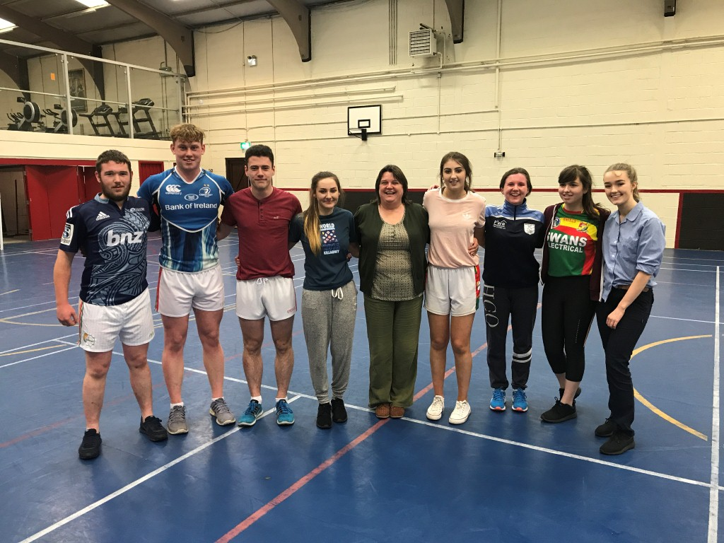
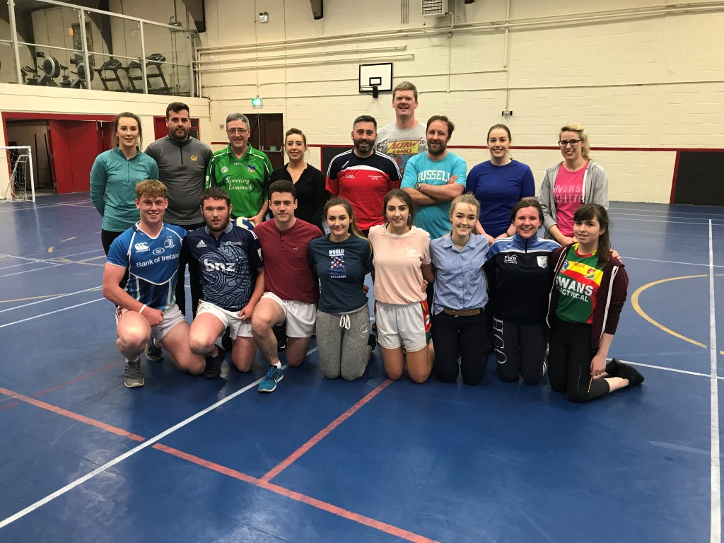
Monday afternoon saw Brendan Hayden from Carlow Gaa come in to do Pelle and Pella with second years. We had over 60 students playing with some girls playing Pella (indoor Hurling) for the first time.
