Active Schools Week day 4 Athletics
Mr O’ Reilly Travelled to the south Leinster Athletics with students and two teams made the finals while two more came home with Medals

First year girls 4 x 100m who made relay final
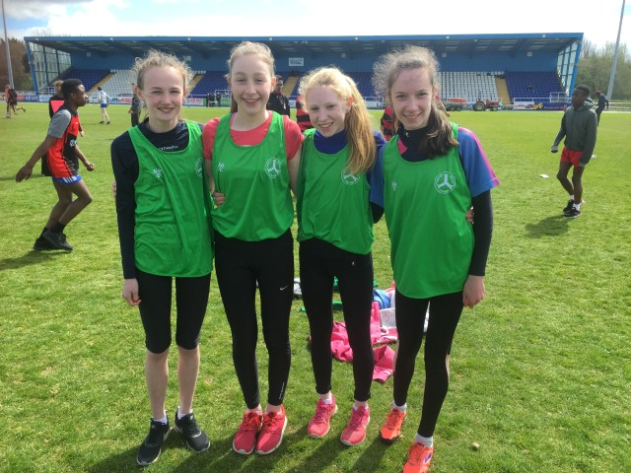

The Junior Girls relay team that made the 4 x 100 m final
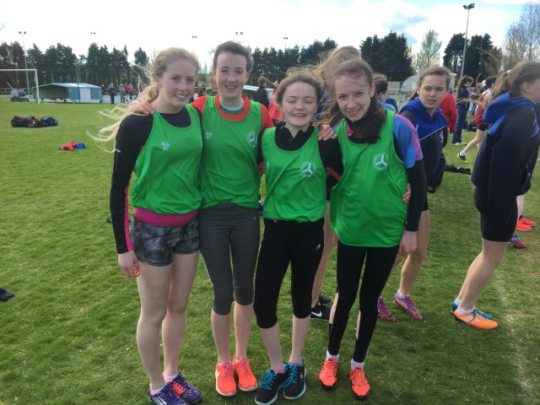

Dean Holmes won silver in the inter boys 1100m steeplechase
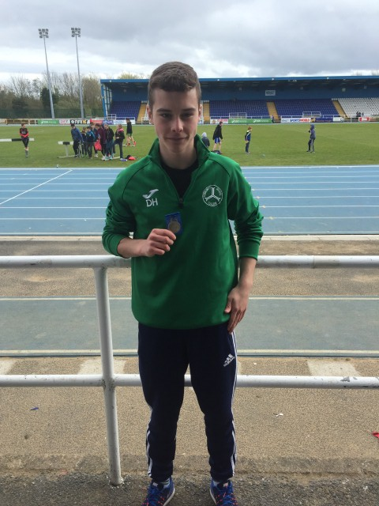

Aoibhean Brennan won Bronze in the 1100 meter minor girls
